- Purpose
  - The purpose of this document is to describe the procedure for assembling the Disk Head on the Genesys Machine.
- Scope
  - This SOP applies to all equipment assembly team members. The process applies to the following machine ID’s:
EP50323EQS0600BE1200 – 26” Disc Head Assembly
EP50324EQS0600BE1200 – 28” Disc Head Assembly
EP50325EQS0600BE1200 – 32” Disc Head Assembly
- Responsibilities
  - The operations manager/supervisor is responsible for enforcing this SOP.
- Materials
  - The proper materials needed for this process are listed on the machine work order.
- Definitions

- Procedure
  - Start the head assembly by placing the proper sized weldment on the table. (E28933 for 26” / E28916 for 28” / E28934 for 32”)
  - Attach the proper disk head shroud (E29571 for 26” / E29570 for 28” / E29572 for 32”) to the weldment using 2 bolts (E81089) and 2 washers (E28622). Sitting the assembly on the blocks will make this easier. You may need to tap out the holes (5/16-18 tap) to be able to thread the bolts in.
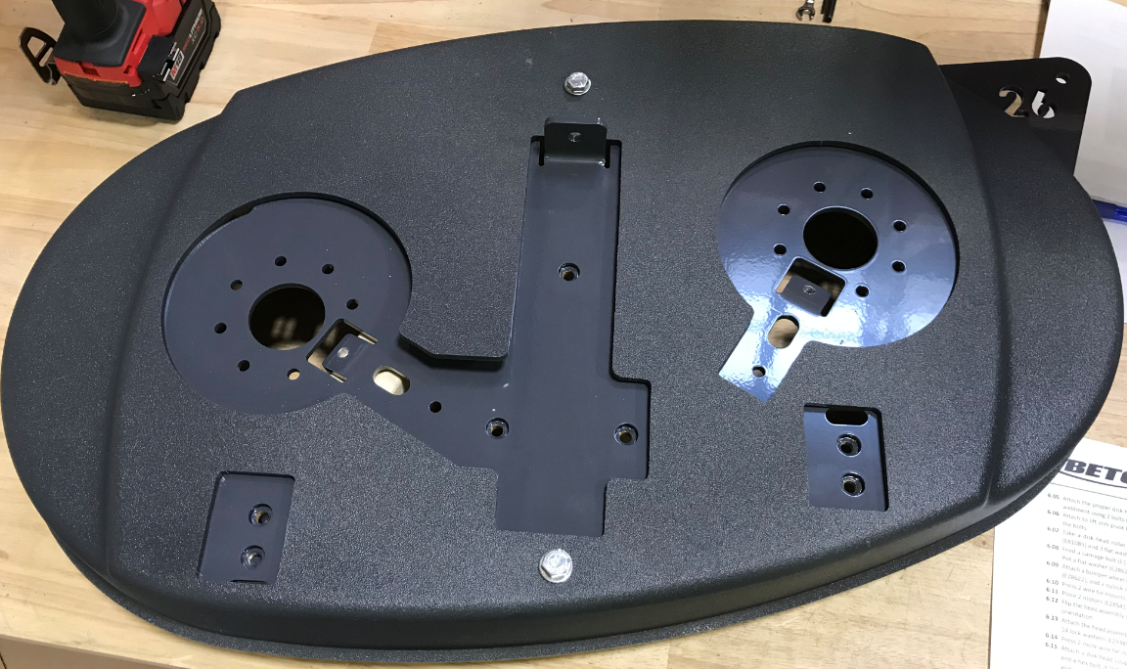
  - Attach two lift arm pivot brackets (E29514) using 2 hex bolts (E81089) and 2 washers (E28622) each. Use blue Loctite on the bolts. They are error proofed, so orientation is only allowed 1 way.
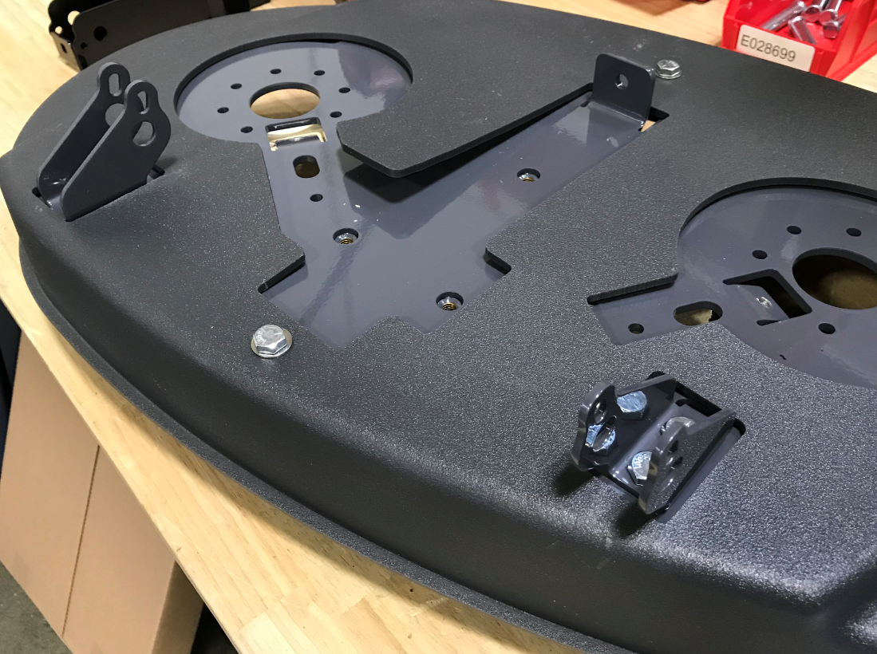
  - Take a disk head roller bracket (E28654) and attach it to the frame weldment using 3 bolts (E81089) and 3 flat washers (E28622). Leave the bolts loose at this point.
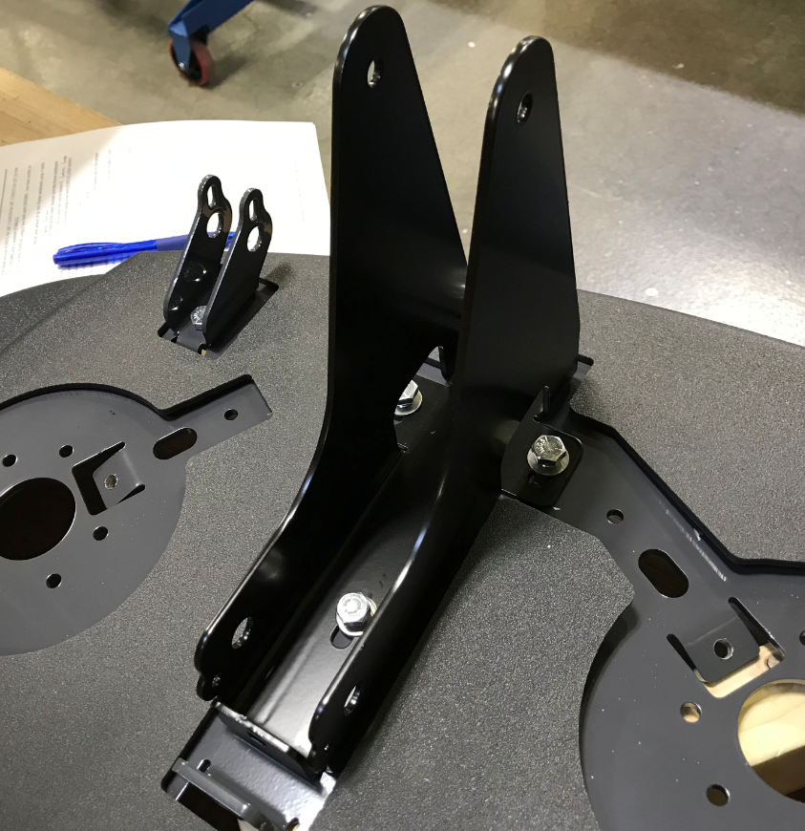
  - Feed a carriage bolt (E11043) through the front of the roller bracket and the frame weldment. Put a flat washer (E28622) and a nylock nut (E81063) onto the end to fasten it. Leave it loose at this point.
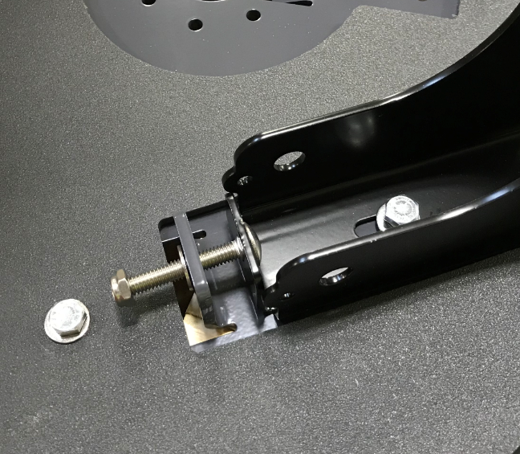
  - Attach a bumper wheel (E28598) to the frame weldment using a hex bolt (E29513), 3 flat washers (E28622), and a nylock nut (E28623). The washers go under the bolt head and between the wheel and the weldment and under the hex nut. The wheel should be able to rotate once tightened. A little movement in the bolts head is not a big deal.
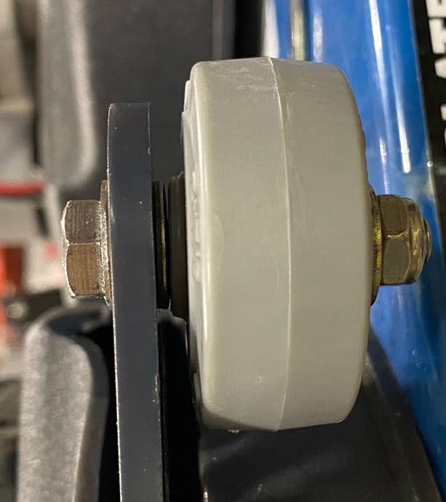
  - Press 2 wire tie mounts (E28621) into the appropriate holes.
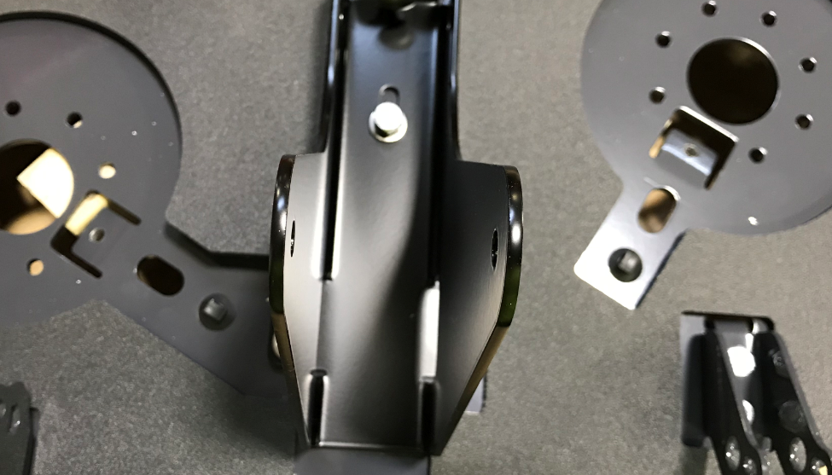
  - Place 2 motors (E28541) onto the table with the shafts pointing up. Keep the green band on them. Use the template provided for motor orientation.
  - Flip the head assembly over and place it onto the motors. Ensure the motors are in the proper orientation.
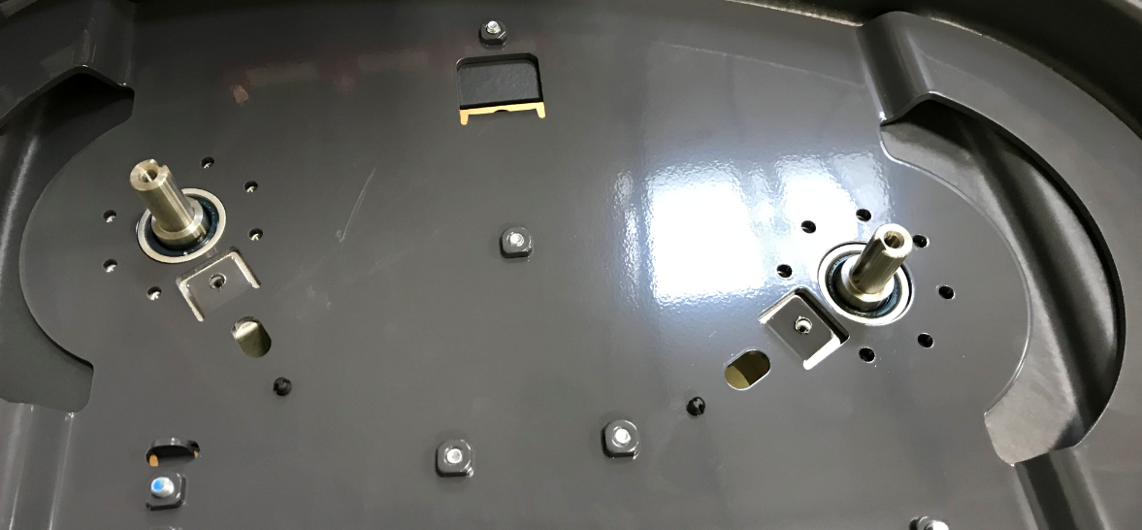
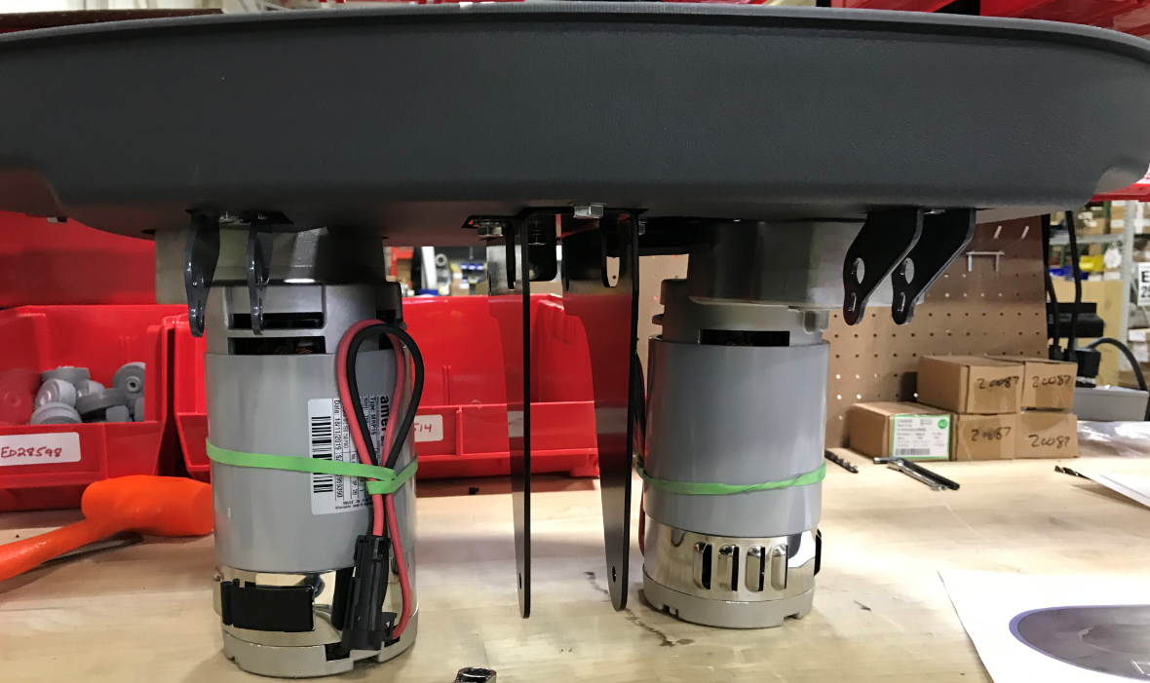
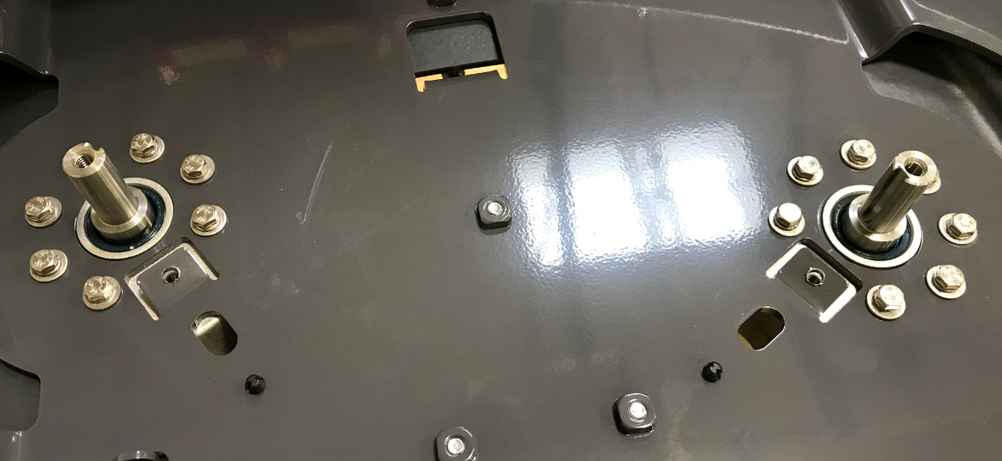
  - Attach the head assembly to the motors using Blue Loctite, 14 hex bolts (E20087), 14 washers (E28617), and 14 lock washers (E29385). Tighten the bolts to 7 ft-lbs min. Mark the orientation of the bolt head.
Mark the bolts

  - Press 2 more wire tie mounts (E28621) into the appropriate holes.

  - Cut 2 pieces of 3/8” tubing (E28609) that are 14” long. Feed them through the holes in the deck as shown. Position the end of the hose so that it is about ½” from the motor shaft. Attach the hose with a zip tie (E83523) to the zip tie mounts on the bottom of the deck.
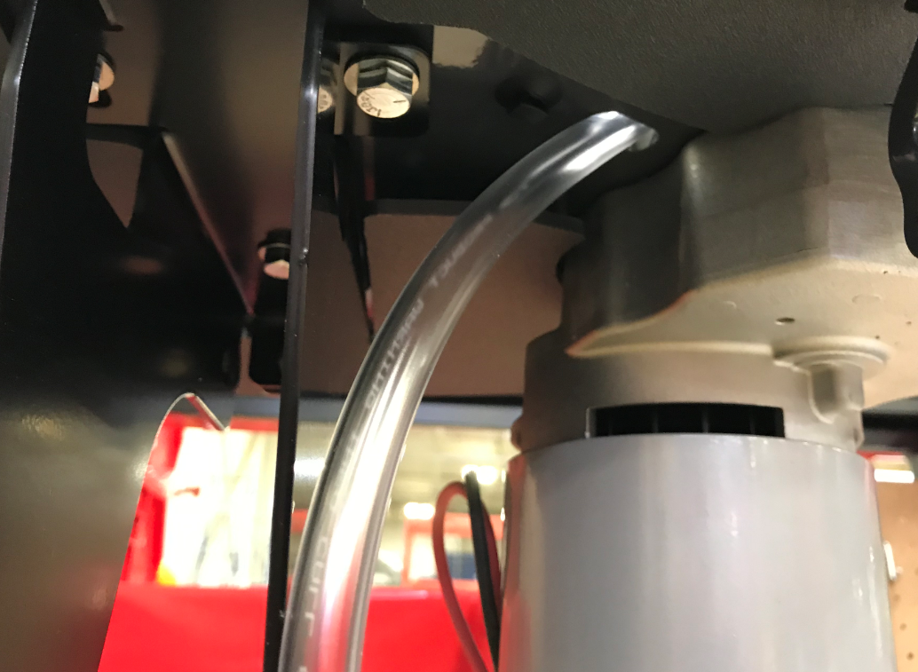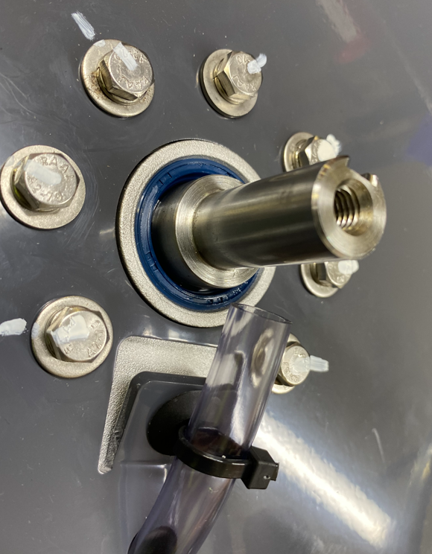
½”
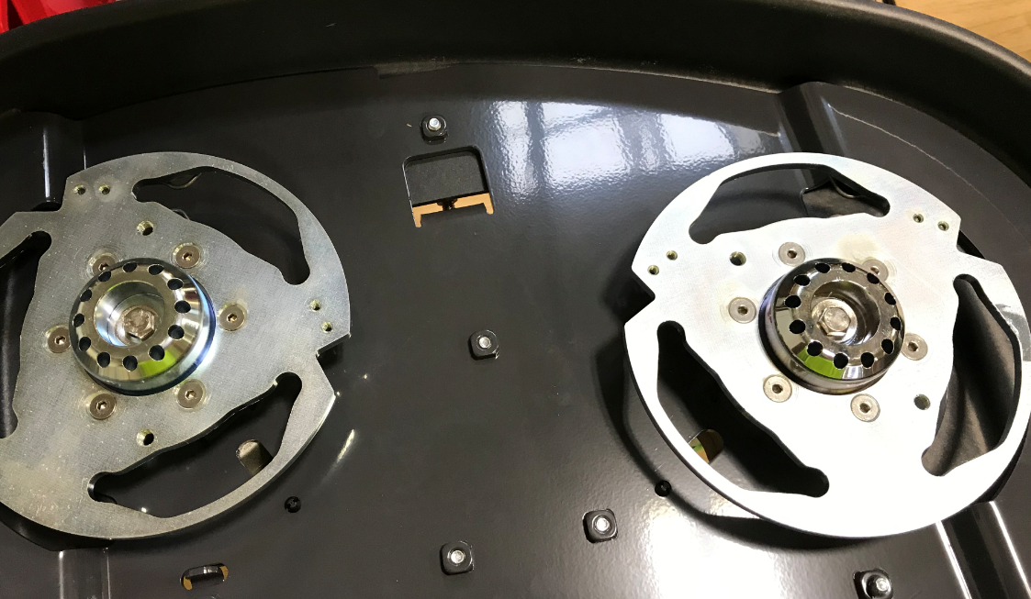
  - Put some anti-seize compound on the motor shafts. Attach a disk head coupler to each shaft using a machine key (E29389), and washer (E29388), and a hex bolt (E29426). Use Blue Loctite on the bolt. Ensure the couplers are a mirrored set and are installed on the correct side of the deck. Tighten the bolts to 15 ft-lbs. Mark the orientation of the bolt head, washer, and hub with a straight line.
Front of machine
Clip
Clip
Bumper Wheel

  - The hose water feed lines should be right next to the coupler shaft and pointing into the holes in the disk alignment coupler.
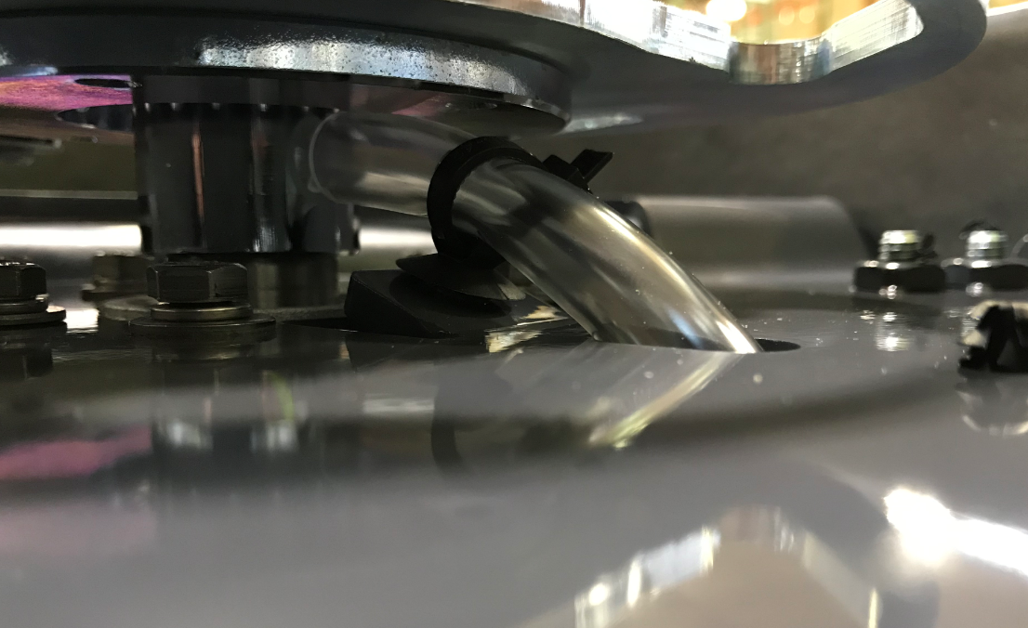
Hose is next to the coupler shaft and feeding into the holes that lead to the floor
  - Flip the head assembly back over.
  - Install another zip tie (E83523) into each of the two top zip tie mounts. Tighten and trim the extra.
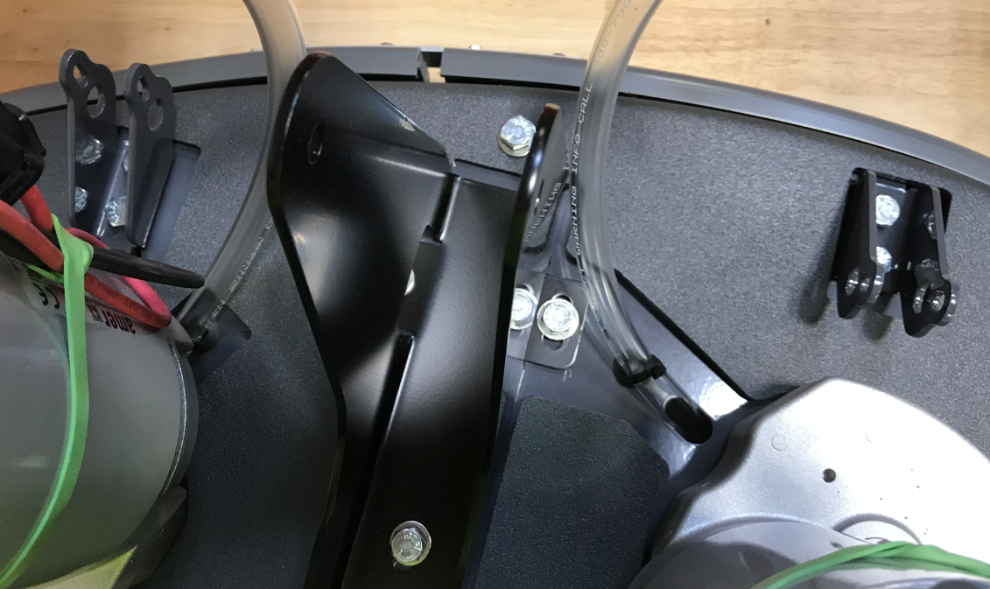

- References (optional section as needed)

- Training Guide

Functional Training Groups Requiring Training
Equipment Assembly Group

- SOP Change Control

Date of Change | Reason for Change
TBD | This is the first version of the S.O.P. hence there are no revisions to this document.
8/13/2021 | Added QC checks and bolt torques
11/6/2023 | Updated to current process
4/2/2025 | Updated and reformatted

Approvals

Submitter/Author Approval:__________________________________ Date:______________________

Management Approval:______________________________________ Date:______________________

QAU Approval:_____________________________________________ Date:______________________

